QUESTION 1 – ERROR DEBUGGING [30 Marks]

You are given a Java program Hotel.java with errors (syntax and/ or logical errors). The program defines four classes that are Customer, Room, and Hotel. The program can be used to show customer information and room information. Below (Figure 1.1) is the source code of the Hotel.java program. Open the program and write your name and matric number on lines 4 and 5 of the source code before proceeding to the next instructions.

01  02  03  04  05  06  07  08  09  10  11  12  13  14  15  16  17  18  19  20  21  22  23  24  25  26  27  28  29  30  31  32  33  34  35  36  37  38  39  40  41  42  43  44  45  46  47  48  49  50  51  52  53  54  55  56  57  58  59  60  61  62  63  64  65  66  67  68  69  70  71  72  73  74  75  76  77  78  79  80  81  82  83  84  85  86  87  88  89  90  91  92  93  94  95  96  97  98  99  100  101  102  103  104  105 | // Hotel.java  // TEST 2 – Question 1  // SECJ2154 – 2023/2024-2  // Name: ???  // Matric No.: ???  import java.ArrayList;  class Customer {  private String name;  private int id;  public void Customer(String name, int id) {  this.name = name;  this.id = id;  }  public int getId() {  return id;  }  @Override  public String toString() {  return “Customer{name: “ + name + “, id: “ + id + “}”;  }  }  class Room {  private int roomNumber;  private String type;  public Room(int roomNumber, String type) {  this.roomNumber = roomNumber;  this.type = type;  }  @Override  public String toString() {  return “Room{roomNumber: “ + roomNumber + “, type: “ + type + “}”;  }  }  class Hotel {  private ArrayList customers;  private ArrayList rooms;  public Hotel() {  customers = new ArrayList();  rooms = new ArrayList();  }  public void addCustomer(Customer customer) {  customer.add(customers);  }  public void removeCustomer(int id) {  for (int i = 0; i < customers.size(); i++) {  Customer customer = customers.get(i);  if (Customer.getId() == id) {  customers.remove(id);  break;  }  }  }  public void addRoom(Room room) {  room.add();  }  public void displayCustomers() {  for (Customer cust : customers) {  System.out.println(customers);  }  }  public void displayRooms() {  for (Room room : rooms) {  System.out.println(rooms);  }  }  public static void main(String[] args) {  Hotel hotel = new Hotel();  hotel.addCustomer(new Customer(“Aliza”, 101));  hotel.addCustomer(new Customer(“Hafiz”, 102));  hotel.addRoom(new Room(201, “Single”));  hotel.addRoom(new Room(202, “Double”));  hotel.displayCustomer();  hotel.displayRoom();  hotel.removeCustomer();  System.out.println(“After removal:”);  hotel.displayCustomers();  }  }

Figure 1.1: The source code of Hotel.java program
Study how all the classes were instantiated and used in the program (Figure 1.1) . Debug the errors, compile, and run the program to successfully generate the output as in Figure 1.2 below. You are NOT ALLOWED to remove or change any statements that do not cause errors in the program. Only update statements that cause errors in the program.
Customer{name: Aliza, id: 101}
Customer{name: Hafiz, id: 102}
Room{roomNumber: 201, type: Single}
Room{roomNumber: 202, type: Double}
After removal:
Customer{name: Hafiz, id: 102}
Figure 1.2: The output for Hotel.java program

QUESTION 2 – PROGRAMMING [70 Marks]

You have been tasked with developing a banking system for Beacon Bank. Figure 2.1 shows the class diagram of the banking system provided to you.

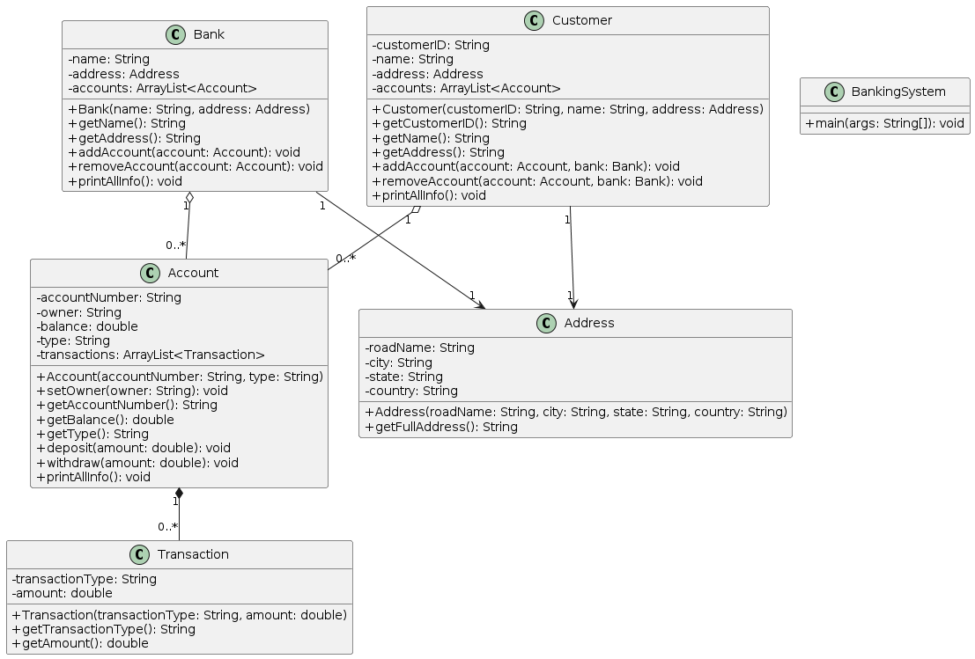i
Figure 2.1: UML Class Diagram for Beacon Bank Banking System

Below is the description for each of the classes:

- Bank class:
A bank can have multiple accounts.
  - The addAccount method will add an account object to the ArrayList of a particular Bank object. Vice versa for the removeAccount method.
  - The printAllInfo method will display the details as shown in the first paragraph of Figure 2.2.

- Account class:
An account can have multiple transactions, but transactions are associated specifically with an account.
  - The setOwner method will be used when an account is added to a customer (in the Customer class) to link that added account to the owner’s name.
  - The deposit method will update the new balance according to the amount deposited. This method will also add the transaction into the transaction ArrayList and is implemented so that if an account is removed, the associated transactions are also removed. Vice versa for the withdraw method.
  - The printAllInfo method will display the details as shown in the second or third paragraph of Figure 2.2.
- Customer class:
A customer can have multiple accounts, but an account can only be associated with one customer.
  - The addAccount method will add an account object to the ArrayList of a particular Customer object. This method will also add the account object to the bank object and set the owner of that account. Vice versa for the removeAccount method.
  - The printAllInfo method will display the details as shown in the fourth paragraph of Figure 2.2.

- Address and Transaction class:
The Address and Transaction classes are used to store the address and transaction information.

Figure 2.2 shows the expected output from the complete implementation.
Bank Name: Beacon Bank
Bank Address: Jalan Kebudayaan, Skudai, Johor, Malaysia
Number of Account(s) Registered: 2
List of Account(s):
1. Account #: A001, Type: Savings
2. Account #: A002, Type: Current

Account #: A001
Owner: John Doe
Type: Savings
Balance: 800.0
Number of Transaction(s): 2
List of Transaction(s):
1. Type: Deposit, Amount: 1000.0
2. Type: Withdrawal, Amount: 200.0

Account #: A002
Owner: John Doe
Type: Current
Balance: 2000.0
Number of Transaction(s): 1
List of Transaction(s):
1. Type: Deposit, Amount: 2000.0

Customer Name: John Doe
Customer ID: C001
Customer Address: Jalan Pendidikan, Skudai, Johor, Malaysia
Number of Account(s) Registered: 2
List of Account(s):
1. Account #: A001, Balance: 800.0, Type: Savings
2. Account #: A002, Balance: 2000.0, Type: Current

Bank Name: Beacon Bank
Bank Address: Jalan Kebudayaan, Skudai, Johor, Malaysia
Number of Account(s) Registered: 1
List of Account(s):
1. Account #: A001, Type: Savings

Customer Name: John Doe
Customer ID: C001
Customer Address: Jalan Pendidikan, Skudai, Johor, Malaysia
Number of Account(s) Registered: 1
List of Account(s):
1. Account #: A001, Balance: 800.0, Type: Savings
Figure 2.2: Example of expected output from the complete implementation of Beacon Bank Banking System

The skeleton of the source code is provided in the BankingSystem.java file. Based on the class diagram and the description given, complete the implementation for all classes: Bank, Account, Customer, Address, and Transaction in the BankingSystem.java file.
(55 marks)

Based on the example expected output in Figure 2.2, complete the implementation of the main method. Refer to the comments provided in the BankingSystem.java file in the main method.
(15 marks)

